|  |  |  |  |  |  |  |  |  |
| --- | --- | --- | --- | --- | --- | --- | --- | --- |
| Forecast Values | |  |  |  | Compiler Engine Information | | |  |
|  |  |  |  |  |  |  |  |  |
| Stand ID: | | 509159 | | | GYPSY Model: | | 2009-May-21 | |
| Stand Type: | | Natural |  |  | Application: | | 20100713p | |
| Stand Age: | | 120 | years |  | COM DLL: | | 20100329b35 | |
| Spatial: | | NO |  |  |  |  |  |  |
| BA adjusted: | | YES |  |  |  |  |  |  |
|  |  |  |  |  |  |  |  |  |
| Input Data | |  |  |  |  |  |  |  |
|  |  |  |  |  |  |  |  |  |
| Species | | totage | topht | den | ps | ba | utilization | |
| AW |  | 120.0 | 23.11 | 730 |  | 28.87 | 13/7/30 | |
| SB |  |  |  |  |  |  | 15/10/30 | |
| SW |  | 81.0 | 23.11 | 365 |  | 14.43 | 13/7/30 | |
| PL |  | 105.0 | 23.11 | 365 |  | 14.43 | 13/7/30 | |
|  |  |  |  |  |  |  |  |  |
| Calculated Attributes | | |  |  |  |  |  |  |
|  |  |  |  |  |  |  |  |  |
| Species | | bhage | y2bh | si_bh | si_t | n0 | sdf | psi |
| AW |  | 115.9 | 4.1 | 15.1 | 14.4 | 48,329 | 3,054 |  |
| SB |  |  |  |  |  |  |  |  |
| SW |  | 73.4 | 7.6 | 18.2 | 16.2 | 588 | 465 |  |
| PL |  | 98.1 | 6.9 | 17.1 | 15.7 | 6,368 | 1,503 |  |

Tesera Gypsy

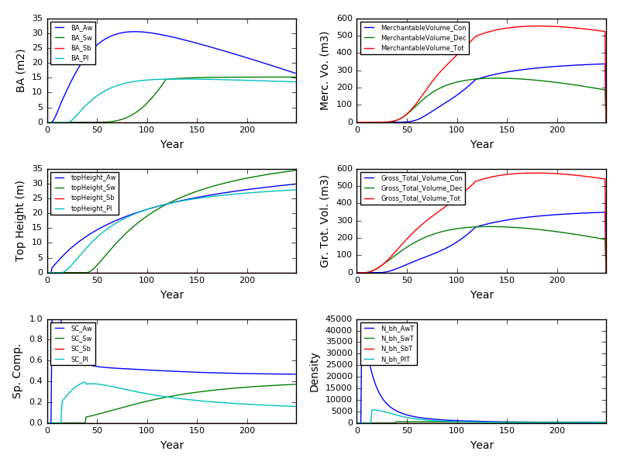

Excel Gyspy

